Digital Audio Processor

Instruction Manual

Contents

1. Technology Overview 2

1.1. Audio Input Section 2

1.2. Audio Output Section 2

1.3. Audio Flow 4

2. System Structure 5

3. Hadrware 6

3.1. Specifications 6

3.2. Front Pannel 6

3.3. Rear Pannel 7

4. Software 8

4.1. Software Download 8

4.2. Using The Software 8

4.3. Audio Module Parameters 10

4.3.1. Input Source 10

4.3.2. Expander 11

4.3.3. Compresser&Limiter 12

4.3.4. Auto Gain Control 13

4.3.5. PEQ 14

4.3.6. GEQ 15

4.3.7. Feedback 16

4.3.8. Gate 16

4.3.9. Ducker 17

4.3.10. ANC 18

4.3.11. AutoMixer 18

4.3.12. Echo Cancellation 21

4.3.13. Noise Supression 22

4.3.14. Matrix 22

4.3.15. HighPass&LowPass Filter 23

4.3.16. Delay 24

4.3.17. Output 24

4.3.18. File Menu 25

4.3.19. Setting Menu 25

4.3.20. Help Menu 31

4.4. USB SoundCard 32

# Technology Overview

## Audio Input Section

The DSP can have up to 8 fixed analog audio Input, connected via a detachable balanced Phoenix connector. The analog Input portion can support microphone, or line level signals. Each Input can provide +48VDC phantom power supply.

The front-end amplification gain and phantom power supply are easily controlled via the DSP Controller.

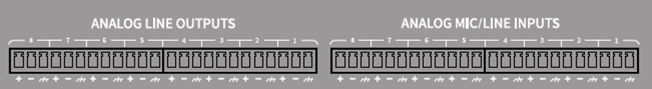

**The A/D technical indicators are as follows:**

**Sampling rate:** 48kHz

**THD+N:** <-100dB @4dBu

**Dynamic range:** 110dB

**Audio format:** 24Bit MSB TDM

## Audio Output Section

The first stage of the analog Output part is the D/A converter (DAC). The DSP uses an advanced 24-bit 256X sampling converter. Like the A/D converter, the multi-bit architecture is used to achieve a wider dynamic range, but it has the same excellent distortion characteristics as a regular unit digital to analog converter. By setting the unit gain (0dB) with the volume control, the analog Output portion is corrected to +4dBu with a dynamic margin of 20dB. This means that the 0dBFS digital signal is equivalent to the +24dBu Output signal. If additional signal levels are required, they can be easily achieved by changing the volume.

**D/A technical indicators are as follows:**

**Sampling rate:** 48kHz

**THD+N:** <-100dB @4dBu

**Dynamic range (A weight):** 112dB

**Audio format:** 24Bit MSB TDM

## Audio Flow

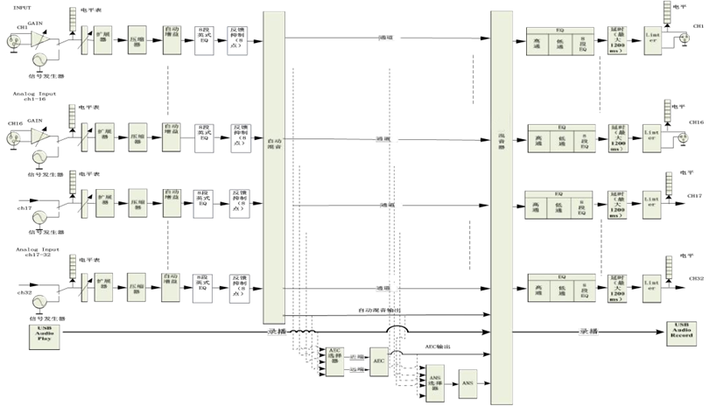

# System Structure

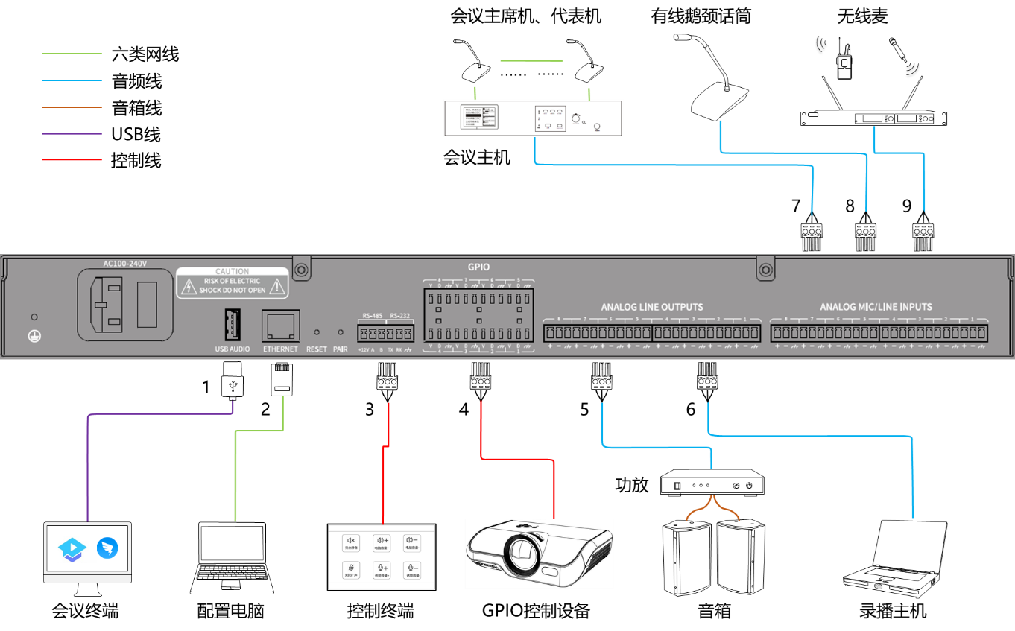

Devices are connected through the interface of the back panel:

1, USB2.0 A type interface, support bidirectional audio data transmission.

2, RJ45 interface, can be connected to external configuration computer.

3, RS232, RS485 interface, serial control interface, can be connected to external control terminal.

4, GPIO control interface, external GPIO control device.

5, Configured as the line Output SPEAK interface, external power amplifier or active speaker, for local sound reinforcement Output or play remote audio signals.

6, Configured as the line Output MIX interface, can be connected to external recording equipment.

7, Configured as a microphone interface, can access the hand-in-hand conference host.

8. It is configured as a microphone interface, which can access the wired gooseneck microphone.

9. It is configured as a wireless microphone interface, which can access the wireless microphone host.

# Hadrware

## Specifications

**Sample rate/quantization bits:** 48K/24bit

**Input gain:** 0/3/6/9/12/15/18/21/24/27/30/33/36/39/42/45/48 dB

**Phantom power supply:** +48V/10mA max

**Frequency response (20~20KHz) :** ±0.5dB

**Maximum level:** +18dBu

**THD+N:** < -100dB@4dBu

**Input dynamic range:** 110dB

**Output dynamic range:** 112dB

**Channel isolation @1kHz:** 108dB

**Input impedance (balanced connection):** 5.4KΩ

**Output impedance (balanced connection):** 600Ω

**Working power supply:** AC110~240V 5Hz-60Hz

## Front Pannel

|  |  |  |
| --- | --- | --- |
| **Serial number** | **Name** | **Instructions** |
| 1 | POWER indicator | Power indicator, keep on after power on. |
| 2 | RUN indicator | Run indicator light, flashing slowly indicates normal operation. |
| 3 | NETWORK indicator light | The network Linkage indicator is steady on when the PC control terminal is Linkage through the network. |

## Rear Pannel

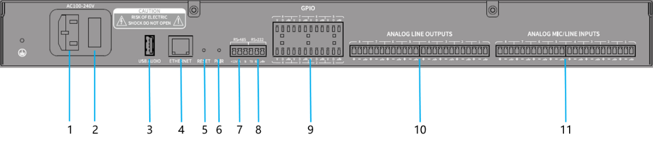

|  |  |  |
| --- | --- | --- |
| **Serial number** | **Name** | **Instructions** |
| 1 | Power port | 100-240V AC, 50/60Hz. |
| 2 | Power switch |  |
| 3 | USB2.0 Type A port | Supports bidirectional audio Data transmission. |
| 4 | ETHERNET | Ethernet interface, external configuration computer. |
| 5 | RESET | Reset the factory configuration button, long press the 3s device to restart and restore the factory configuration. |
| 6 | PAIR | Remotely debug pair keys. |
| 7 | RS485 | RS485 serial control interface, external control terminal or central control device. |
| 8 | RS232 | RS232 serial control interface, external control terminal or central control device. |
| 9 | GPIO | GPIO control interface, external control terminal or central control device. |
| 10 | ANALOG LINE OUTPUTS | Line Output interface (1-8), can connect power amplifier, active speaker, recording and broadcasting server and other equipment. |
| 11 | ANALOG MIC/LINE INPUTS | Microphone/line Input interface (1-8), can be connected to microphone, DVD, conference host and other devices. |

# Software

## Software Download

**Device Linkage and configuration**

The default IP address of the processor is 168.182.102.36. The subnet Mask is 255.255.255.0. Make sure both the PC and the processor are on the same network segment of the same local area network. If the PC and processor are on different network segments, go to the PC Network Settings to modify the Network Parameter. In addition, downloading software installation programs requires the PC to have access to the public network, so the PC needs to be configured with dual IP addresses.

**Software Download**

After the previous step, open the PC browser and Input “168.182.102.36” to open the software download page. To log in, Input user name “admin”, password “123456” and click “Login”. Download the installer according to the prompts (some models need to choose to download PC software), and install it after the download is completed.

## Using The Software

After opening the software, the following main screen is displayed:

电脑的屏幕

Click the button in the upper right corner of the main interface, all processors on the Network will be automatically searched. The user will Linkage to the specified processor as required, and the network indicator will light up after the connection.

**Custom edit processing module**

Click the button in the upper right corner, right-click on the Input or Output channel processor module, the editing dialog box appears, you can replace the current processing module, delete, copy and other Output, click the editing button again you can exit the editing mode of the prime and you can choose whether to upload the proper parameter to the host.

When editing the module, note the change in the lower right corner. When it turns red钟表的特写

中度可信度描述已自动生成, that is, when CPU1 is greater than or equal to 100, editing or uploading the device cannot be completed, an error message will be displayed.

**Other**

Click to restore the device to factory Settings; Click to mute all Output Channel; Click to save the current configuration; Click to import the local configuration. Click to synchronize the two Channel gain controls.

## Audio Module Parameters

### Input Source

**Sensitivity:** the microphone gain, 0/3/6/9 12/15/18/21/24/27/30/33/36/39/42/45/48 is a, a total of 17 files are optional.

**Phantom:** External capacitive microphone feed, when needed to activate. Do not open the line with Input or no power supply to prevent damage to external devices.

**Phase:** The phase of the audio signal is reversed 180°.

**Mute:** Mute the Channel.

**Sine Wave:** Drag the frequency to produce a sine wave at the specified frequency (20 to 20 KHZ). The Output level can be adjusted as required in dBFS. Use the fader to adjust or click the text Input box to specify a value.

**White Noise:** White noise has equal energy in each frequency component. Observe it on a spectrum meter with constant bandwidth, it has a flat spectrum. At this point the frequency adjustment is ineffective and the level is available.

**Pink Noise**: The frequency component power of pinknoise is mainly distributed in the low and medium frequency bands, where it decreases at a rate of 3dB/Oct across the spectrum. At this time, the frequency adjustment is not effective and the level is available.

In addition, right click on each fader in the main interface to see the following menu Settings.

**Group settings:** Quickly opens the group Settings screen and groups Input or Output channels.

**Minimum Gain and Maximum Gain:** Limits the maximum and maximum gain of the Channel.

### Expander

Expanders are the opposite of compressors in principle, being able to extend the dynamic range of a signal. The most basic difference between these two devices is that the compressor works on signals above a threshold, while the expander works on signals below a threshold. The expander is able to make small signals even smaller.

The extender has the following control Parameter:

**Threshold:** This level must be exceeded by the signal to open the expander (to allow the signal to pass through). In practice it is generally set to the Environment Noise of the magnitude.

**Ratio: The** slope below the Threshold point on the gain curve. The Action approaches the Gate when the ratio is set high.

**Attack:** Duration of the Input signal, above the Threshold, the time **it** takes to open the extender. A faster opening time allows for faster transient opening of the expander.

**Release: The** time it takes for the gain to return to a value below the Threshold after the Input signal drops below the Threshold.

Whether it is startup time or release time, its effect is only to reduce the rate of change of the amount of gain Damping.

### Compresser&Limiter

**Compresser**

The compressor reduces the dynamic range of signals above a user-set Threshold, and signal levels below that Threshold remain.

The compressor has the following control Parameter:

**Threshold: The** signal level is above this value the compressor starts to reduce the gain. Any signal that exceeds the Threshold is considered an overshoot signal and its level is reduced under normal circumstances. The greater the range of the signal beyond the Threshold, the more the level will be Damping.

**Ratio:** This is compression ratio. The ratio determines the extent to which the overshoot signal Damping towards the threshold level. The smaller the compression ratio, the easier it is for the signal to be higher than the threshold. Once the signal exceeds the threshold, the Parameter of the compression ratio determines the ratio of the change in the Input signal to the change in the output signal.

**Attack and Release:** In order to retain the natural onset of vibration, it is usually desirable that an initial portion of the level will pass through the compressor unaffected (or only slightly affected). To achieve this, you need to slow down the compressor's reaction time. Similarly, if there is a large and rapid Damping of the signal gain, as well as a rapid recovery, the suction effect will occur. The set up time and release time of the compressor are designed to avoid this happening. The build up time can determine the speed at which the gain Damping occurs, while the release time can determine the speed at which the gain recovers.

Output gain slip Block: If the compressor significantly reduces the signal level, it may be necessary to increase the Output gain to maintain the volume. This lifting Operation is consistent for all parts of the signal and is independent of the setting of other Parameter of the compressor.

**Limiter**

It has only one key task: to ensure that the signal does not exceed the threshold level, no matter what the circumstances. By adjusting the control Parameter of the compressor, it can be made to work in a very similar way to the limiter. The core of the working principle of the limiter is the content of the signal below its true Relation threshold level, and how the gain Damping begins to be generated before the signal overshoots. The restriction period is completed through two processing stages, in the first stage is only slightly limited, but does not deal with overshoot signals, and in the second stage, if the signals produce overshoot, they will be in a very drastic manner Damping.

The limiter only provides two Parameter: Threshold and release time. For signal processing, the occasional clipping should be solved by the limiter, while the frequent clipping usually requires the attenuating of the signal level.

### Auto Gain Control

Automatic gain control (AGC) is a special case of a compressor whose threshold is set at a very low level, medium to slow build time, long release time, and low ratio. The purpose is to raise a signal with an uncertain level to a target level while maintaining dynamics. Most automatic gain controls include some kind of silence detection to prevent loss of gain attenuation during silence. This is the only feature that sets an automatic gain control apart from a normal compressor/limiter.

Use automatic gain control to normalize the level of a CD player playing background, foreground, or waiting music to eliminate some paging microphone level variations.

Automatic gain control includes the following Parameter:

**Threshold: When the signal level is** lower than the threshold, the Input/Output ratio is 1:1. When the signal level is above this threshold, the Input/Output ratio varies with the ratio control setting. Set this threshold to background noise just above the Input signal level.

**Ratio: The** ratio between the change in the level of the Input signal above the threshold and the change in the level of the Output signal.

**Target level:** Desired Output signal level. If the signal is above this Threshold, the controller compresses the signal according to the ratio.

**Attack:** Controls the level reaction time above the Threshold.

**Release:** Controls the level response time of signals below the Threshold.

### PEQ

The main purpose of the equalizer is to correct for overemphasized or missing frequency ranges, whether they are wide or narrow. In addition, equalizers can help us narrow or widen the frequency range, or change the Size of certain components of their spectrum. In simple terms, an equalizer changes the timbre of a signal.

The equalizer has the following control Parameter:

**Type:** Default parameter equalization, optional high and low frame filter and high and low pass filter. Each type of filter has different forms and can accomplish different functions.

**High&Low pass:** The reference frequency of the filter is called the cut-off frequency, and the frequency component on one side of the cut-off frequency can be completely passed through the filter, while the frequency component on the other side of the cut-off frequency is continuously Damping. Among them, High pass can let the frequency component above the cutoff frequency pass, and filter out the frequency component below the cutoff frequency. On the contrary, Low pass allows the frequency components below the cutoff frequency to pass, while filtering out the frequency components above the cutoff frequency.

**High&Low shelf:** also known as shelf filter. The overhead filter is defined as a partial gain increase or Damping of the frequency above the set frequency. The low frame filter is a partial gain increase or Damping of the frequency below the set frequency. The set frequency is not the cut-off frequency of 3dB, but the center point of the falling or rising edge of the filter. The Q value affects the peak value and has a mathematical relationship with the peak value.

**Freq (Hz) : The** center frequency of the filter.

**Gain (dB) : The** decibel value at which the gain increases or Damping at the center frequency.

**Q/OCT:** Quality factor of the filter. The Q value can be adjusted from 0.02 to 50; The adjustable range of OCT value was 0.029 to 11.289

There is a switch under each equalizer that enables or disables the equalizer. The Parameter setting of each equalizer takes no effect when the equalizer is disabled. The equalizer has a master switch that enables or disables the module.

### GEQ

Using constant Q-value technology, each frequency point is provided with a push-pull potentiometer, no matter raising or Damping a certain frequency, the bandwidth of the filter is always unchanged.

### Feedback

Feedback suppression modules should always be used in conjunction with good system design and engineering practices, not as a substitute for good system design. Traditional methods such as limiting the number of microphones on, minimizing the Distance from the source to the microphones, positioning microphones and speakers for minimal feedback, and equalizing the room for a flat response should still be used. After that, feedback suppressors can be used for additional gain. Feedback suppressors do not magically solve a poorly designed system or increase the sound gain beyond the physical limits of the system.

图形用户界面

The feedback suppression module automatically detects and suppresses acoustic feedback in the audio system. The module distinguishes between feedback and expected audio based on the characteristics of the signal. When feedback is detected at a certain frequency, a notch filter is automatically added to the feedback frequency point to Damping it.

Each Channel has a feedback suppression. To enable the feedback suppression module, click the Open button to enable the feedback suppression of the corresponding Channel.

The following are the adjustable Parameter for feedback suppression:

**Freq:** The adjustment can modify the feedback suppression frequency

### Gate

The main purpose of the Noise gate is to Damping signals below the threshold, and such Damping signals are usually Noise.

The Noise gate can be adjusted Parameter as follows:

**Threshold:** The signal exceeds the Threshold and starts and Damping when the signal is smaller than the Threshold.

**Attack:** Start time refers to the speed at which the Noise door opens.

**Release:** Therelease time is the opposite of the start time, which refers to the speed at which the Noise door closes.

### Ducker

When the level of a Channel exceeds the specified Threshold, the level of another Channel will be attenuated, which is the evasive effect.

**REF source:** Reference signal selected by the Ducker device. Channel from 1-8 can be selected as the reference signal

**Threshold:** When the reference signal is higher than the Threshold, it Damping. When the reference signal is lower than the Threshold, it recovers.

**Depth:** The amount of maximum reduction by the evaded signal. The amount that is lowered can be adjusted via the left slider.

**Attack time:** Thetime when the reference signal is higher than the Threshold and begins to Damping the avoided channel signal.

**Release time:** After the reference signal is lower than the Threshold, the time when the evaded signal recovers to the Size of the original signal.

### ANC

Automatically adjust Output volume according to ambient Noise sensing and handling.

**Maximum Gain:** The maximum volume that can be adjusted.

**Minimum Gain:** The minimumamount that can be adjusted.

**Gain-Sense Ratio:** The ratio of increase or Damping.

**Speed:** Speed of increase or Damping.

**Trim:** Gain.

**Noise Threshold:** More than the start boost gain, less than Damping.

**Distance:** Distance between the reference signal and the local signal.

### AutoMixer

In the conference room, if multiple microphones are turned on to the Same gain level, and only one person is speaking, the result may not be very clear, other microphones will pick up room noise, reverberation, etc., when these signals are mixed with normal microphone signals, it will greatly reduce the quality of the mixed audio Output, and the whole sound amplification system is very easy to scream. And the whole sound reinforcement system is very easy to whistle, can not get enough sound gain. In order to solve this problem, it is necessary to turn off other microphones that are not in use for a while. Automatic mixers can complete this shutdown process and react much faster than manual Operation.

A gain-sharing automatic mixer built into the processor supports 8 Channel of audio Input. Each Channel in the auto mix matrix has a direct Output, unaffected by auto gain and Channel faders, only by Channel muting. A Channel suitable for a fixed volume, such as a Channel for background music, needs to be kept at a fixed level without being controlled by automatic mixing; For example, if the chair microphone needs to be kept in the normally on State and its gain is not affected by automatic mixing, the Output of the channel can be adjusted directly in the Output matrix routing. At this point, the automatic mix button of the Channel can also be turned off, its gain will not be adjusted, and the signal level on this Channel will not affect the gain on other Channel.

The automatic mixing module has two sets of control Parameter:

**1. Master control Parameter**

**Gain:** Controls the main Output volume **of automatic mixing**

**Slope:** Slope control affects the Damping of lower levels. A low Channel will also be Damping more at a higher slope. The slope control works in a similar way to the ratio control on the expander.

When the slope is set to 2.0, it achieves a relatively ideal gain sharing and is the preferred value in use.

**Response:** A faster time ensures that the head of the spoken word is not cut off. The Operation is more Smoothing when the time is slow. Practice shows that the response time is around 400ms for the best results. Autogain is designed to turn the microphone on much faster than it is turned off, so even with a 400ms response, the head of the spoken word is usually not subtracted. If you set a slower time of a few seconds, the auto mixer response time will have a longer hold time, and the last active Channel will save the open State for a few seconds.

**Mute**: Mute the automatic mixing Channel

**2. Channel control Parameter**

**AM:** Each Channel has an auto mix on/Off button that needs to be turned on for Channel participating in auto mix. It can also be turned off, and the Channel does not participate in automatic mixing.

**Mute:** Mute the Channel, but does not affect the Channel through the auto mix Output sound.

**gain:** Adjust the gain fader to increase/decrease the proportion of volume in automatic mixing.

**Priority:** The automatic mixing algorithm is affected when a high-priority Channel overtakes a low-priority channel. The Parameter ranges from 0 to 10. The larger the value, the higher the priority.

Priority control allows high priority Channel to Coverage low priority Channel, thus affecting the automatic mixing Channel. The control can take on a range of values from 0 (lowest priority) to 10 (highest priority), with a default value of 5 (standard priority). You can adjust the priority by using the slider, or you can Input a specified priority between 0 and 10 by clicking the edit box. Increasing this Numeric Value increases the priority.

If two Size of the same signal level size, the channel with a higher priority will have a higher automatic gain. If two Channel differ by one unit of priority, the Channel with one higher priority gains an additional 2dB (Hypothesis the slope of both Channel is set to 2.0) of automatic mixing gain. For example, if the priority of Channel 1 is set to 6 and the priority of Channel 2 is set to 3, the Channel Input levels of both Channel have the same Channel, and the Channel will get an additional mixing gain of 6dB more than the Channel 2. Note that the slope setting of the main control Parameter will also affect the difference in mixing gain caused by the Channel's preferred weight. If the slope is set to 3.0, then a priority unit difference between Channel results in a gain difference of 4dB. If all Channel have the same priority, leave all Settings at the default level 5.

Note: Extreme priority differences between Channel, such as 0 and 10, need to be used with extreme care in some Settings. If a very high priority Channel is picking up signals from the speaker, such as background Noise, it is possible to mask a lower priority Channel, even if the very high priority Channel is not in use, the higher the slope of the problem is more serious. If this problem is encountered during installation and commissioning, consider adding a Noise gate or expander between the automatic mixers on the highest priority Channel, while setting the threshold cell to a threshold or level where the expander will not be opened by background Noise or speaker recognition.

### Echo Cancellation

Acoustic Echo Cancellation or AEC is a digital audio signal processing technique used for audio and video teleconference when the conversation takes place between participants in a local conference room and one or more speakers at a certain Distance. AEC programs increase the Phonetic of remote speakers by eliminating Acoustic echoes generated in the local room.

The echo cancellation module applied in remote call can facilitate local amplification of remote Phonetic signal and Damping off the interference of acoustic echo. Its basic working principle is to simulate the echo channel, estimate the echo that may be formed by the remote signal, and then subtract the estimated signal from the Input signal of the microphone, so that the Input Phonetic signal no longer contains the echo, in order to achieve the purpose of echo elimination.

There is only one echo cancellation module in DSP Controller. The local Input and remote Input mixer are preset to realize multiple signals participating in echo cancellation, as shown in the figure. There is a Parameter to adjust:

**NLP:** Conservative,Moderate,Aggressive. These three optional types select the level of suppression of the echo.

Note: Echo cancellation module Settings need to be used in conjunction with matrix module Settings for signal routing.

### Noise Supression

Noise suppression module can effectively remove the sound except human voice. Distinguish between human voices and non-human voices, and treat non-human voices as Noise. A piece of audio containing a human voice and Noise is processed by the module and, in theory, only the human voice is left.

There is only one Noise cancellation module in DSP Controller, and a multi-channel mixer is preset to realize the participation of multiple signals in Noise elimination. Some models have AI noise reduction modules, as shown in the figure.

图形用户界面

**Level:** A total of 6dB, 10dB, 15dB and 18dB are available. The meaning of dB is to suppress the Noise to reduce how much dB, the greater the value, the greater the damage to Phonetic, which is unavoidable.

**Level (AI):** There are traditional noise reduction, AI noise reduction level 1, AI noise reduction level 2, and AI noise reduction level 3 to choose from. The effect of AI denoising is better than that of traditional denoising, and the higher the level, the more obvious the effect is. The level is adjusted according to the actual situation.

**De-reverberation:** When speaking in an open environment, there may be reverberation. Turning on can alleviate this reverberation.

### Matrix

The matrix has the dual Operation function of routing and mixing. Horizontal represents Input Channel, vertical represents output Channel, as shown in the figure. If you want the sound source to OUT1 through IN1 Output, then dot the corresponding matrix.

### HighPass&LowPass Filter

The high-low pass filter module can filter out sounds below or above a set frequency.

图形用户界面

Each Output Channel provides a high-low pass module, consisting of a high-pass filter and a low-pass filter. Each filter has the following four Parameter:

**Freq:** The cutoff frequency of the filter.

**Type:** Select the type of filter, there are Bessel, Butterworth, and Linkwitz-riley types.

**Slope:** The Damping Size of the overband of the filter. There are 8 choices: 6, 12, 18, 24, 30, 36, 42, 48dB/Oct. For example, 24dB/Oct indicates that in the transition zone, the frequency is different by one octave, and the amplitude Damping is 24dB.

### Delay

With the delay module enabled on the Channel type, the Input sound will delay the output cell based on the set parameter youdaoplaceholder3.

**Millisecond:** Set the delay time of the delay device. This value ranges from 0 to 500 milliseconds. Both meters and feet are unit values for milliseconds.

### Output

**Phase:** The phase of the audio signal is reversed by 180°.

**Mute:** Set to mute/unmute.

### File Menu

If you are not Linkage to the device, click Open to open an existing default file (extension: *.dpslist).

Click "Save as" to save the preset on the application to the local hard drive for easy copy and storage.

### Setting Menu

**Device setting**

The device name, device IP, hot standby, RS-232 configuration parameters and RS485 configuration parameters can be set.

**Default preset:** Two startup preset modes can be selected. One is to specify any one of the 16 presets as the startup preset, and each startup will be started with the preset. The second is to select the preset of last loading, and the preset used last time before power off is used as the preset for the next boot.

**DHCP:** After enabling the device will automatically obtain an IP address, without the need to manually set the IP address, effective after restart.

**Hot standby:** The dual machine hot standby function mainly achieves data synchronization between the master and slave devices.

Host: When the ‘SetAsHost’ switch is turned on,  will be displayed in the upper right corner of the UI. You can enter the slave IP in the backup device IP box.

Slave: When the ‘SetAsHost’ switch is turned off,  will be displayed in the upper right corner of the UI.

**GPIO setting**

A total of 8 GPIO channels can be configured on the GPIO Settings page, and the input or output can be configured independently. You can export GPIO configuration and import GPIO configuration.

**The input configuration is as follows:**

**Preset:**

Trigger Type: high level trigger/low level trigger/high level trigger, low level cancel/low level trigger, high level cancel, that is, rising edge/falling edge trigger/rising edge trigger, falling edge cancel/falling edge trigger, rising edge cancel.

Preset: When the hardware GPIO port input jump type is consistent with the trigger type set by the software, it switches to this preset.

**Route:**

Trigger Type: Same as above (some trigger types cannot set high level trigger, low level cancel/low level trigger, high level cancel)

Input/Output: Select the input channel for which the output is to be mixed. When the trigger condition is met, mix/cancel the mix action.

**Gain:**

Trigger Type: Same as above (some trigger types cannot be set high trigger, low cancel/low trigger, high cancel)

Channel: Select the input or output channel.

Step: Add a step size of one bit dB to the original gain of the channel

**Mute/Unmute:**

Trigger Type: Same as above (high trigger, low cancel/low trigger, high cancel cannot be set for some trigger types)

Channel: Select the input or output channel.

**The output configuration is as follows:**

**Preset:**

Output Type: High/Low preset: When toggling to this preset, the corresponding GPIO port outputs a high or low level.

**Level:**

Output Type: High/Low

Channel: This specifies the input or output channel

level: This specifies the GPIO output high/low when the specified channel level reaches the set level threshold. Otherwise, the opposite level is output.

**Mute:**

Output Type: High/low channel: Specifies the input or output channel. Output the set high/low level when the channel is muted. Unmute and output the opposite level.

**Group setting**

The group interface is divided into two labels: input and output, and the maximum of four groups can be set under each label. One channel can only participate in one group. Under the same group, their channel volume adjustment and mute adjustment are synchronized.

手机屏幕截图

**Preset Name**

Change the preset name for preset 1-16.

**Panel Settings**

The panel settings include two types of control panels: Button version and OLED screen version. Through the panel settings interface, multiple physical panels can be connected to the DSP device through a network. By configuring the panel again, the purpose of controlling DSP devices through the panel can be achieved.图示

**Offline device:**

Suitable for editing offline devices. Debugging engineers first configure panel parameters locally and then upload them to the online panel. Of course, you can also directly edit the online panel, for example, drag a certain online panel from the online panel area to the panel design area and double-click edit.

There is a circle  on both the panel and device icons. Clicking on this circle draws a line and selects the target device, establishing a connection between the two devices.

Double click on the panel in the design area to enter the panel configuration interface. The configuration of the two types of panels will be described separately below. After the configuration is completed, click the upload icon  on the toolbar to upload the panel configuration to the device.

**Panel configuration:**

1. The following figure shows the OLED screen panel main menu information editing page. Click ‘Add Menu’ and a menu selection box will pop up. Select the corresponding menu item and confirm. After completing the software menu configuration, click the upload icon  on the toolbar to upload the configuration to the panel hardware.

2. The following figure shows the main menu information editing page of the Button panel. After clicking the corresponding button, you can enter the function selection page, select the desired function, and then click OK. After completing the software menu configuration, click the upload icon  on the toolbar to upload the configuration to the panel hardware.

**OLED screen panel operation:**

The OLED screen panel includes an OLED screen and a knob, and the parameters can be set as follows:

Main interface: Display panel name and device IP address

Submenu: Current menu number/total number of displayed menus, status of DSP connection: ONL (online connection), OFL (offline connection).

Rotating the knob will redirect to the corresponding submenu. The submenu will include the following five menu types: (Note: Volume and Mute will synchronize DSP data when connected)

1. Volume: Press the knob to enter editing mode. You can rotate the knob to adjust the volume, and press the knob again to cancel editing mode.

2. Mute: Press the knob to enter the editing state. You can rotate the knob to adjust the mute state: mute/unmute, and press the knob again to cancel the editing state.

3. Preset: Press the knob to enter the editing state. You can rotate the knob to the specified preset menu number. Pressing the knob again will set the preset number and cancel the editing state.

4. Command: Pressing the knob will send the UDP, RS232, or RS485 command set by the user.

5. Matrix: Press the knob to enter the editing state. You can rotate the knob to adjust the matrix selection state, and press the knob again to cancel the editing state

**Button panel operation:**

The buttons will include the following five menu types:

1. Volume: Press the button, the button light will flash, and the semi circular light on the knob will display the volume level. Rotate the knob to adjust the volume. Pressing the knob will cancel the selected button.

2. Mute: The mute status of the corresponding channel will be displayed, and pressing the button can adjust the mute status of the corresponding channel: mute/unmute.

3. Preset: Pressing the button will set the DSP status information corresponding to the DSP preset number.

4. Command: Pressing the button will send the UDP, RS232, or RS485 command set by the user.

5. Matrix: Press the button to adjust the matrix selection status.

### Help Menu

**About:** Displays version number, technical support contact information, etc.

**Document:** Get the current device help documentation.

**Center control command:** View the corresponding control command for the current function.

Click on the corresponding function to display the corresponding control command. Note: There is no central control command for camera tracking.

**Device Info:** View current device version information, etc.

**Check for updates:** Check if a new version of the DSP control software exists.

**Firmware updates:** Update the device firmware.

Select the device to display the device information of the current device. After selecting the firmware update package, click Upgrade to upgrade the device to the corresponding version.

## USB SoundCard

The use of USB sound card has two functional purposes: one is to achieve recording and playing; The second is remote conference on PC, USB sound after echo cancellation and noise cancellation.

**Sound Card Settings**

Linkage to the host computer through the USB data cable of the double-headed Type-A interface. The first Linkage, the computer will automatically install the driver. After the installation is complete, the USB sound card of the current device is displayed in the Player sound card list and recording sound card list of the PC. Select the USB sound card of the current device (the name of the current device sound card is selected based on the actual situation) as the default device to complete the Settings.

